3 6 9 a i . B i z

369 Showroom Check

Administrator Guide
Set up the rounds, define what good looks like, and act on the results.

About This Guide
This guide is for the person who sets the system up and reads what comes out of it. It covers the schedule, the original photographs, who may record, the results, and the housekeeping.
If you only walk rounds, read the User Guide instead - it covers the phone app and nothing else.
You can do almost everything from the phone. A few tasks exist only in the web workspace, and each is marked web only where it appears.
IMPORTANT The system measures; it does not decide. Every result is shown next to the original so a person can judge it. A low score is evidence to look at, never a verdict on somebody.

Your Setup at a Glance
▪ Set the office timezone first - the whole schedule hangs off it, and nothing else is right until it is.
▪ Create the rounds - when checking happens, and how long each window stays open.
▪ Add an original for each view - until you do, nothing can be compared and the app asks for nothing.
▪ Decide video, photographs, or the cleaner's choice - and who is allowed to record at all.
▪ Leave the thresholds alone for a week - then move them to fit what you actually see.
▪ Watch Compare daily, Missed Rounds weekly - one is the room, the other is the habit.

PART 1 FIRST-TIME SETUP

Step 1 Sign In and Find the Gear
Sign in exactly as anyone else does, with the server address, database, username and password.
What marks you out as an administrator is on the Dashboard: a gear icon in the top band, next to the log-out arrow. It appears only for managers. Tapping it opens a sheet titled Configuration with three destinations.
What are you looking at? | What it means
Settings | The five setup tabs - rounds, photographs, video, permissions, retention.
Rounds | The schedule on its own, with an editor for each round.
AI review | The optional written review. Off unless you switch it on.
The red Missed chip | Tappable for you, not for anyone else. Opens the missed-rounds list.
History and Compare tabs | Yours only. Ordinary users see just Dashboard and Profile.

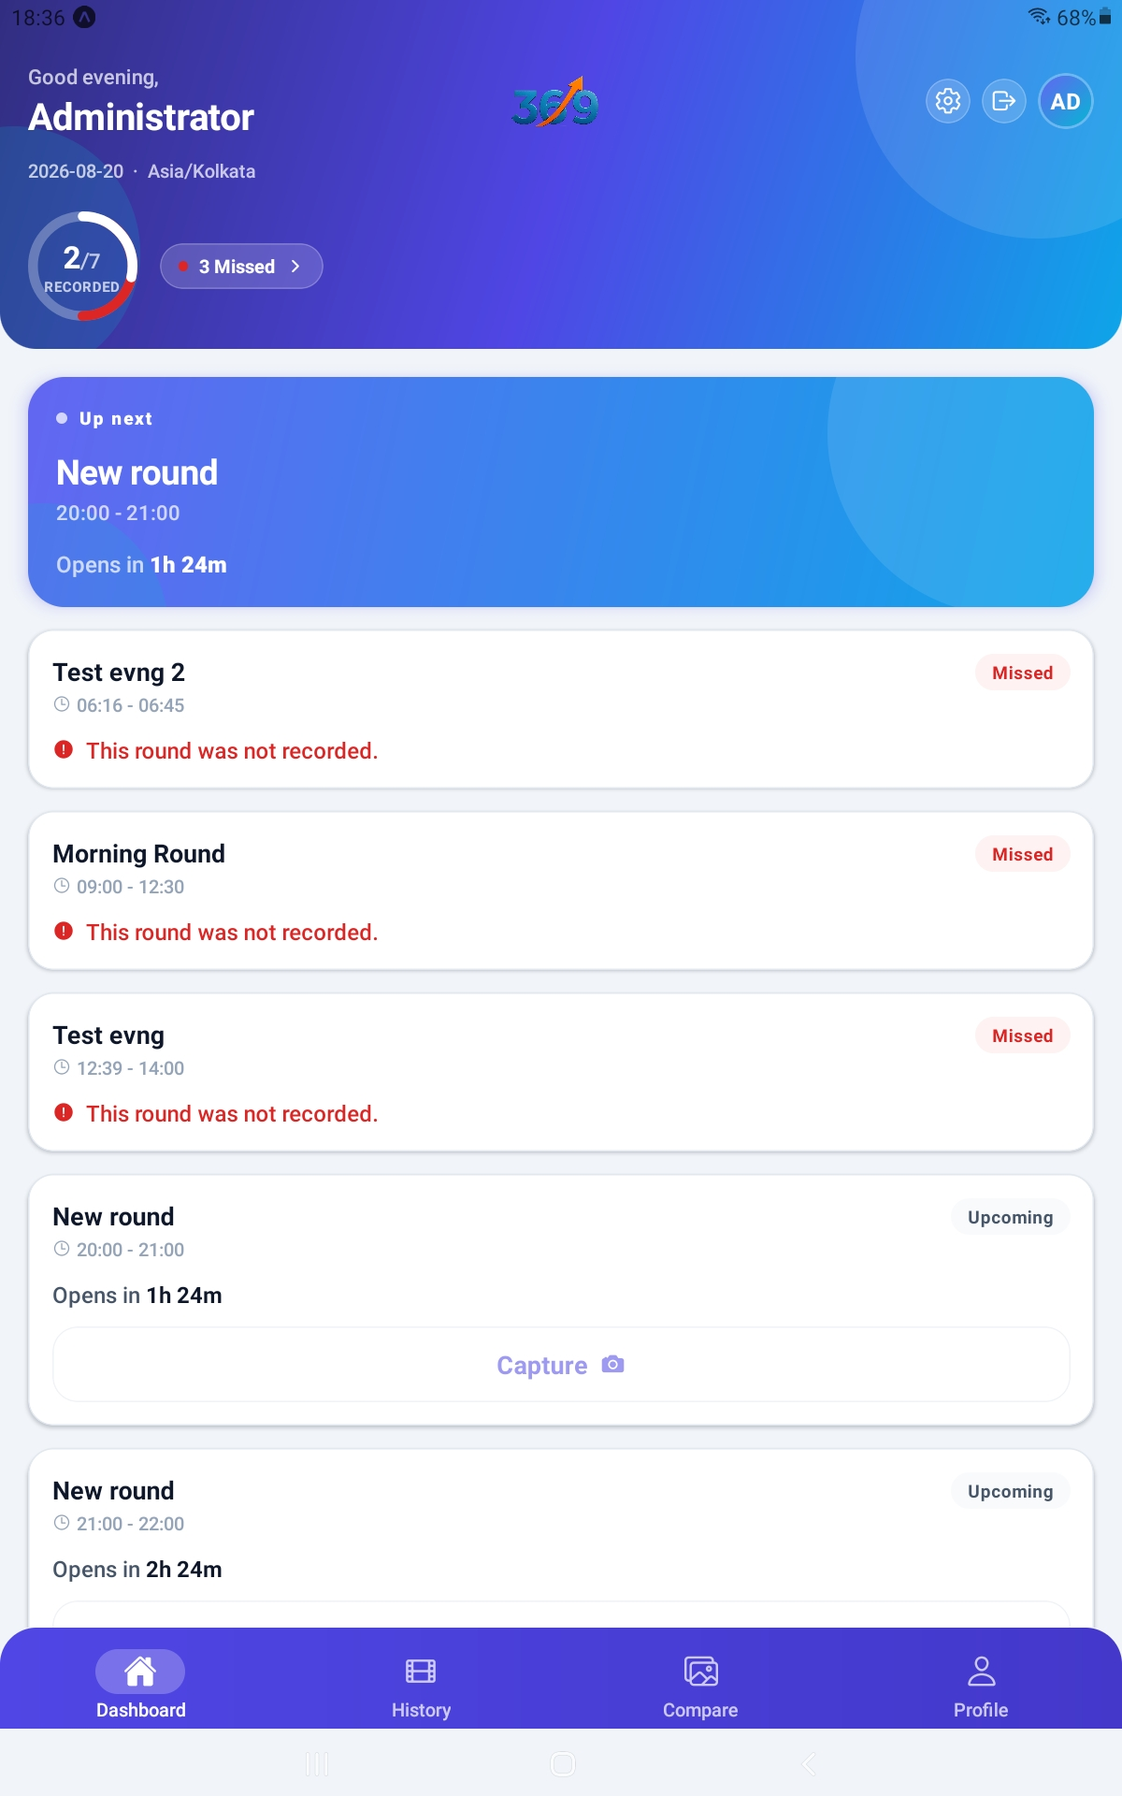
Figure 1. The administrator's Dashboard - four tabs, the gear icon, the progress ring and the missed count.

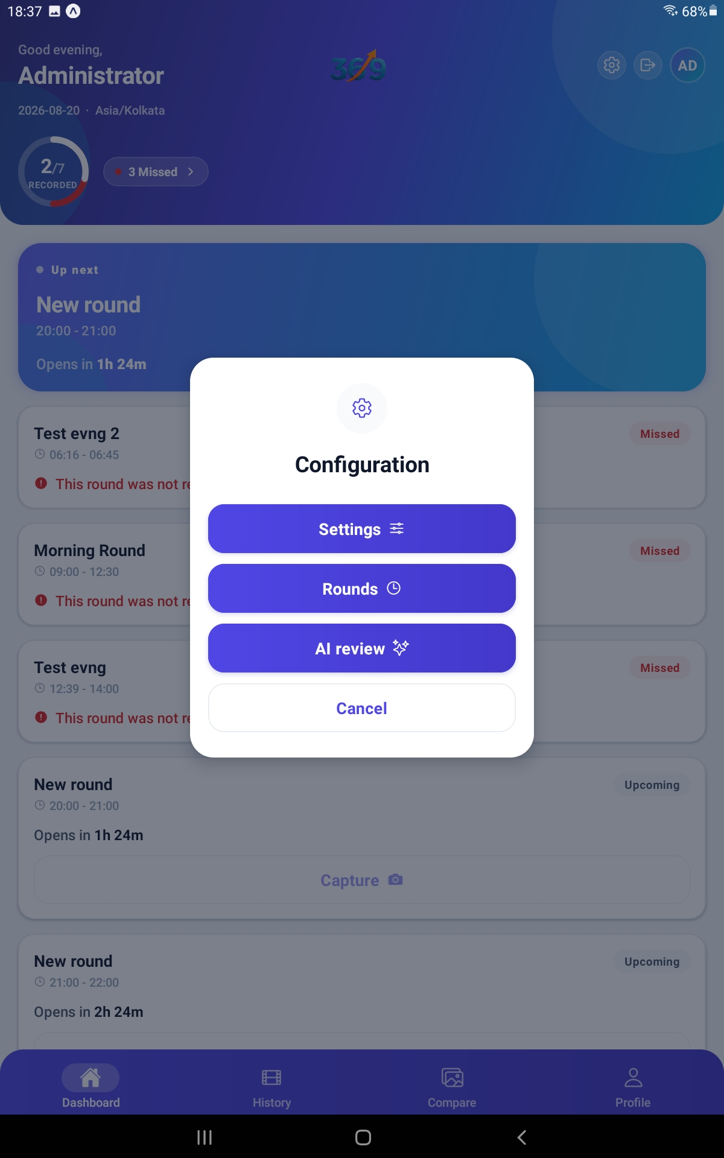
Figure 2. The Configuration sheet, reached from the gear icon.

TIP Anyone with system-administrator rights on the server is automatically a Showroom Check Manager. You do not have to grant the role to yourself.

Step 2 Set the Office Timezone
Open Settings and stay on the first tab, Daily rounds. Set Office timezone to wherever the showroom actually is.
The hint under the field says it plainly: The whole schedule is anchored to this timezone, not to each user's own. A round scheduled for 09:00 opens at 09:00 where the room is, whatever time it is on the phone in someone's hand.
This field saves the moment you pick it. There is no Save button on this tab.
What could go wrong? | What happens
The timezone is wrong | Every round opens at the wrong time of day, for everybody. This is the most damaging single mistake available to you.
It was guessed at install | The system took its best guess from your users' own timezones. Check it rather than trust it.
Your staff are in another country | It does not matter. The setting follows the room, not the people.

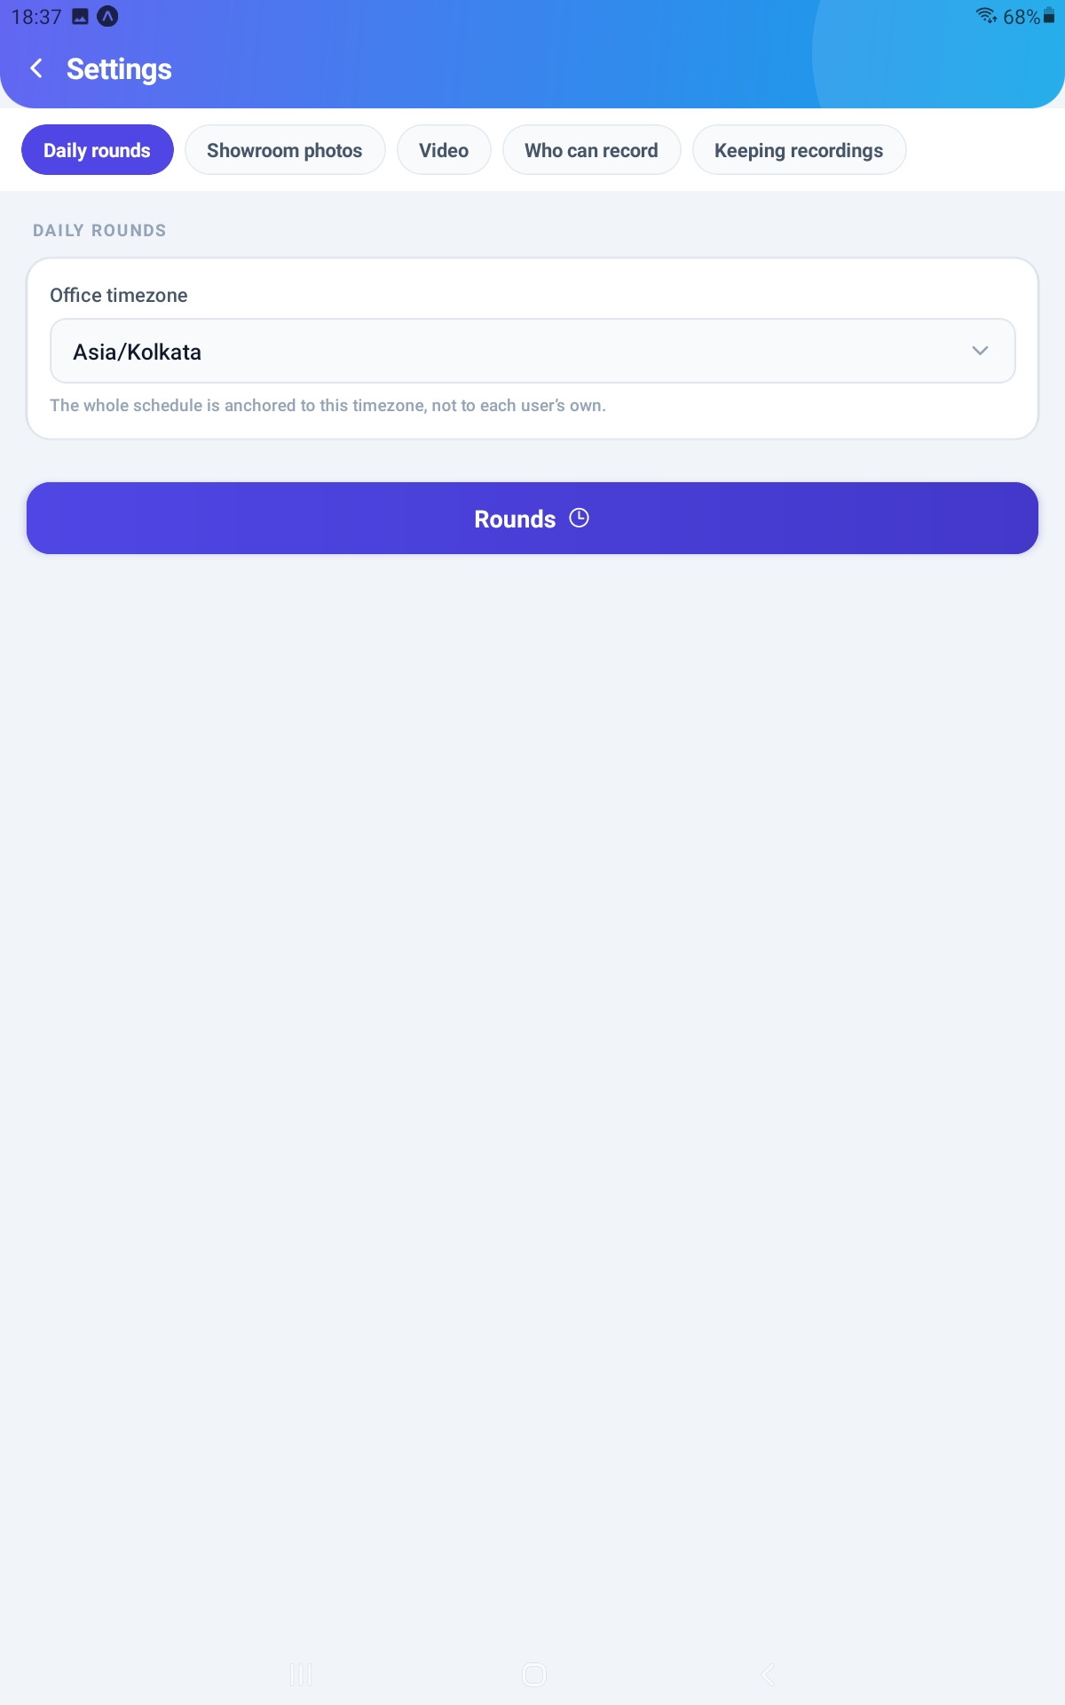
Figure 3. The Daily rounds tab, with the office timezone and the button through to Rounds.

Step 3 Create the Daily Rounds
From Settings, tap Rounds - or reach the same screen from the gear. Each round appears as a card with its name, period, window and days, and a switch to turn it on or off.
Tap Add a round to make a new one. It is pre-filled to start where the last one ended, so it does not clash. Tap any card to open its editor.
What are you setting? | What it does
Name | What the cleaner sees on the Dashboard. Make it recognisable.
Period | Morning, Afternoon, Evening or Night. Groups the round on reports.
Starts at / Ends at | The window. The round can only be captured between these times.
Window length | Worked out for you. Make sure it is long enough for the walk.
Days | Tap each weekday to include it. Sunday is off by default.
Order | Where the round sits in the list.
Instructions | Shown on the dashboard while the round is open.

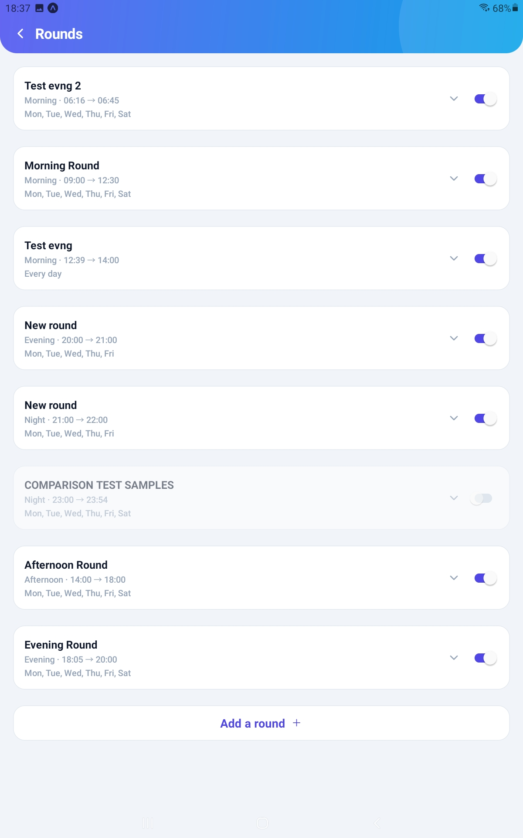
Figure 4. The Rounds list, with each round's window and days, and Add a round at the foot.

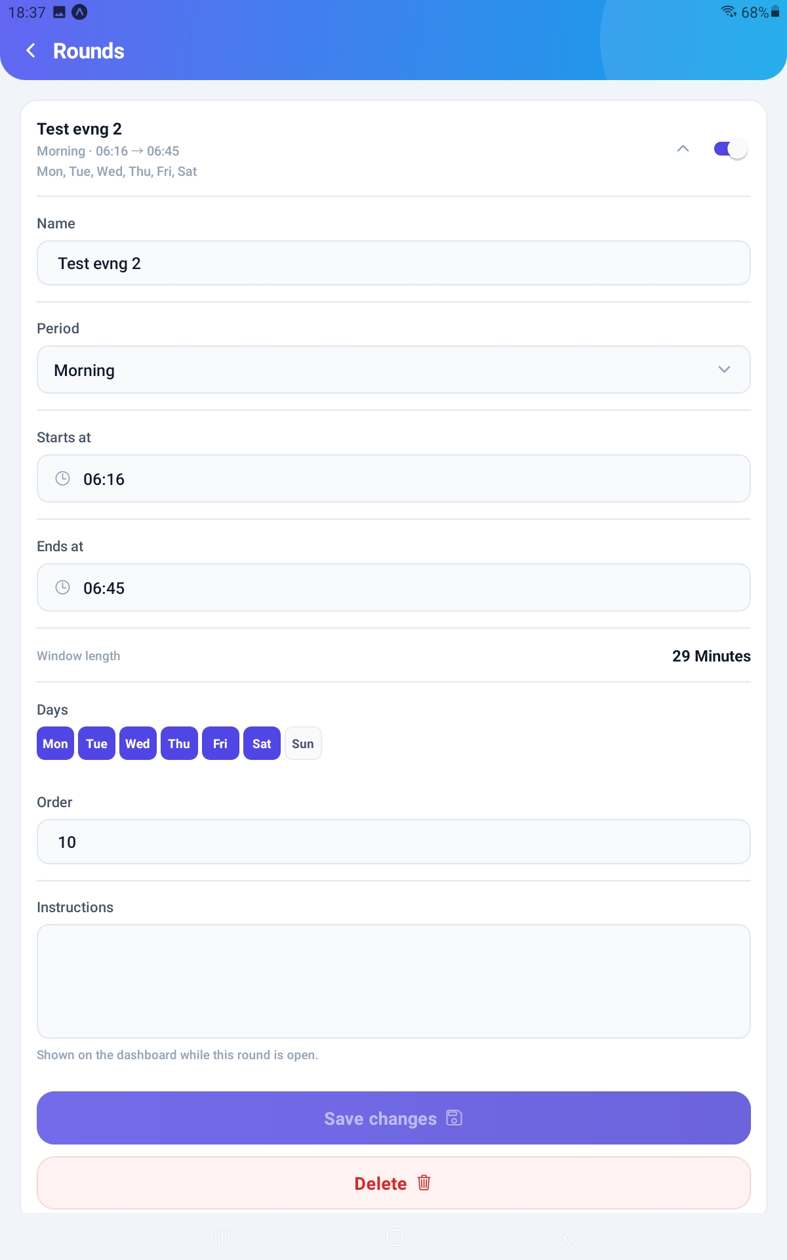
Figure 5. A round open for editing, showing the window, the day chips and the instructions.

IMPORTANT A window cannot cross midnight, and two active rounds cannot overlap on a shared day. A 22:00 to 02:00 night round has to be entered as two separate rounds.

Step 4 Add an Original for Each View
This is the step that decides whether any of this works. Until a view has an original, it cannot be compared, and the app will not even ask for it.
Open Settings, then the Showroom photos tab. There are four views, fixed. Tap one to open its editor, then Take photograph or Choose from phone. Fill in What this shows and What to look for, then save.
What matters most? | Why
Stand where the round is actually walked | Framing matters more than photo quality. An original taken from the doorway will never line up with a round walked from the floor.
Use the same kind of phone the staff use | Held the same way, at the same height.
Shoot in normal working light | Not with the blinds shut, and not at a different time of day than the rounds.
Name it for what it shows | "Bags area" means something to the person holding the phone. "Left" often does not.
Capture the whole view | Not a close-up of one corner.

TIP The best original is one of your own round photographs. Open a round in the web workspace, find the view, and press Use this as the original - the framing then matches by construction. Every round measured against the old picture is re-scored automatically.

IMPORTANT There are exactly four views and there is no way to add a fifth. A view you clear stops being asked for, but the row and its name remain.

PART 2 HOW ROUNDS ARE CAPTURED

Step 5 Choose Video, Photographs, or Both
Open Settings, then the Video tab.
Allow a video round is the master switch. Leave it on and the cleaner chooses, round by round, between one sweep of the room and photographing each view. Turn it off and every round is photographs only.
What are you setting? | What it does
Allow a video round | On, and the cleaner chooses. Off, and it is photographs only.
Clip length and Unit | How long the sweep runs. The single biggest lever on file size.
Quality | Low, Medium or High. Medium is enough for most rooms.
Format | The container the clip is stored in.
Camera | Rear or front. Rear is nearly always right, and it does nothing on a laptop.
Maximum upload | A ceiling per round, protecting the server from one enormous file.
Estimated size per clip | Updates as you change the length and quality. Multiply it out before committing.

IMPORTANT Reading a round out of a video needs feature-matching software on the server. It installs itself when the module is installed or upgraded. If that was refused - usually because the server's account cannot write to its own program folder - this tab shows a warning with an Install it now button. Until it succeeds, video rounds are stored but never scored, and the cleaner is not offered the choice.

No sound is ever recorded, on any setting. This keeps files small, avoids a second permission prompt, and avoids capturing conversations in the office.
NOTE The cleaner now sees the clip played back before it is sent, under Check the recording, with the view names lighting up as playback reaches each one. They can Record again before anything reaches you. Expect fewer sweeps that missed a wall - and note that a re-recorded clip replaces the first, so you will not see the discarded one.

Step 6 Decide Who May Record
On the Who can record tab, choose between everyone with access and a named list. Use the named list where only certain staff should be capturing rounds even though others can see them.
Upload grace period lives here too. It is how long after a window closes an upload is still accepted, and it covers somebody who finished just as the window shut.
Access level | Can see | Can change
No access | Nothing. The app is invisible to them. | Nothing.
User | Their own rounds only, plus the schedule and the originals. | Nothing at all - they can capture a round, but never edit or delete one.
Manager | Everything, including every person's rounds. | Everything, including deleting rounds.

TIP Set the access level per person in the main Settings area of the web workspace, under Users. A person also needs to be on the allowed list here if you have chosen a named list - the two work together.

IMPORTANT Choose Who may record in the web workspace rather than on the phone. The phone's version of this setting does not currently match what the server expects, and a change made there will be refused.

PART 3 READING WHAT COMES BACK

Step 7 Read the Comparisons
Open the Compare tab. Rounds are grouped by day, newest first, each with its verdict and score. Tap a round to see each view: the original on the left, what was captured on the right.
A round's score is the worst of its views, never the average. One bad wall is the entire point, and averaging would hide it.
Verdict | What it means | What to do
As expected | The view matches its original. | Nothing.
Worth a look | A little different. | Glance at the two pictures.
Something has changed | Clearly different from the original. | Check the room.
Could not line up | The two pictures could not be matched. The score is about the wrong pixels. | Almost always framing. Retake the original from where the round is walked.
Not compared | No comparison happened - no original, or the sweep never showed the view. | Add the missing original, or ask for the view to be covered.

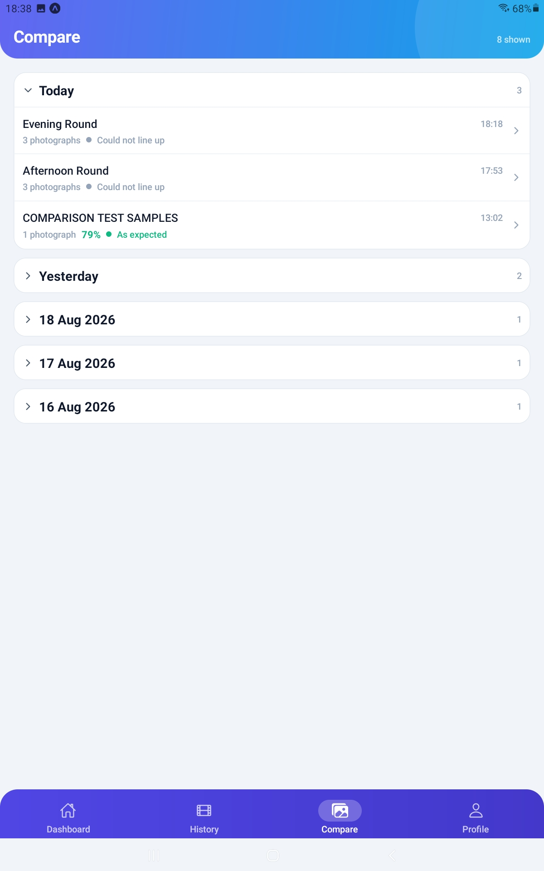
Figure 6. The Compare tab, with rounds grouped by day and their verdicts.

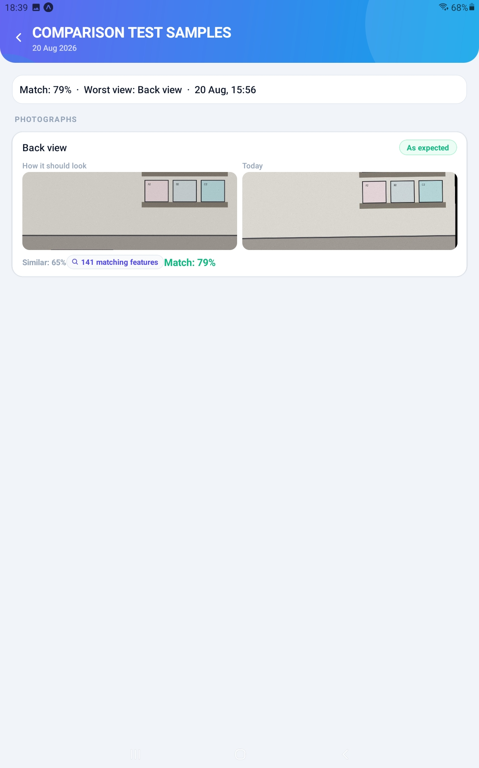
Figure 7. A comparison in detail - the original beside what was captured, with both numbers.

Similar and Match answer different questions and must not be confused. Similar is how much of the same thing is in both pictures - an emptied room is still highly similar to its original, because all the same walls are in shot. Match is whether anything moved, and only appears once the two pictures were successfully lined up.
TIP Two photographs of a room where nothing has moved do not score 100. The light changes and nobody stands in exactly the same place twice. Expect a good match in the seventies or eighties.

Step 8 Work With a Single Round
Open the History tab and tap a round to see it in full: the clip, the photographs, who captured it, when it started and ended, and the measured detail.
Two actions live here that nobody else has. Compare again re-scores the round as things stand now - useful after replacing an original or moving a threshold - and tells you which views moved. Analyse with AI sends the pictures for a written review, if you have that switched on.
What are you looking at? | What it means
Match (worst view) | The round's headline score - its weakest view.
Average match | The mean across the views. Context, not the verdict.
Worst view | Which view produced the headline score.
Compared at | When the measurement was last run, not when the round was captured.
cut short | The clip ended before its configured length.
Not reviewed | No AI review has been run on this round.

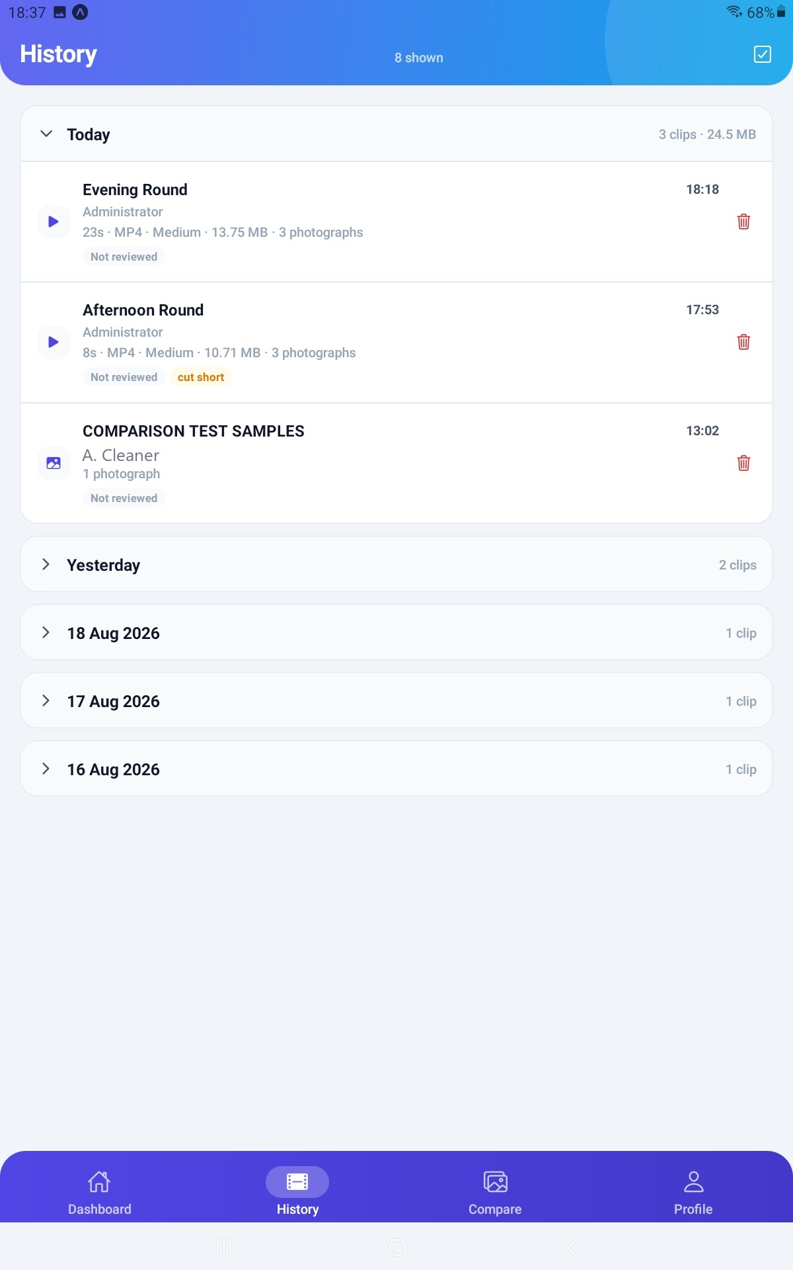
Figure 8. The History tab, grouped by day, with each round's size, format and badges.

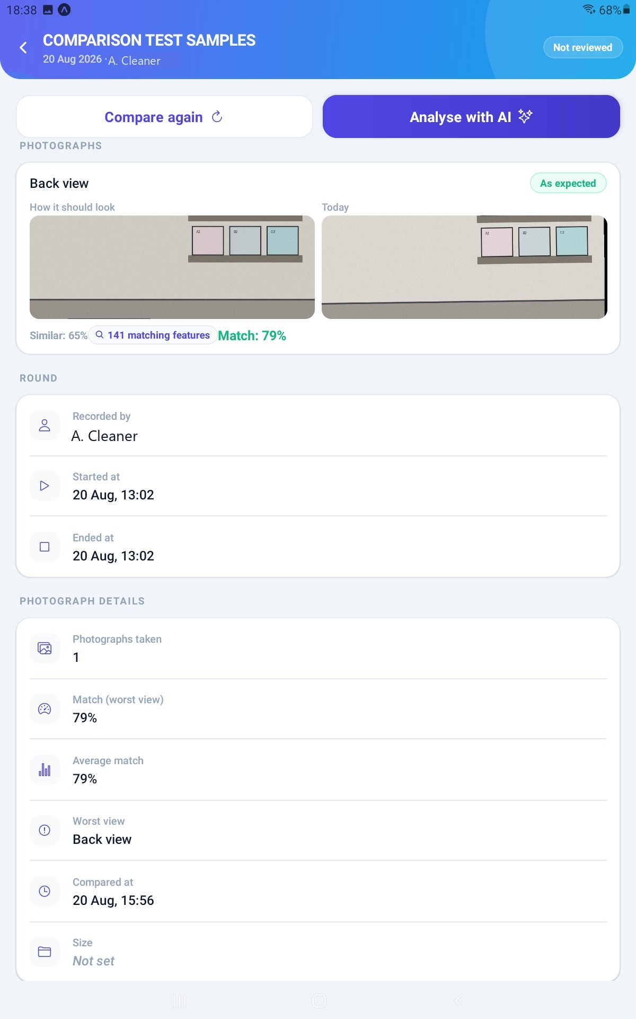
Figure 9. A round in detail, with Compare again, Analyse with AI and the measured figures.

IMPORTANT Re-running a comparison scores against the original as it stands now, not as it stood then. Where an original has been replaced since, the card says so.

Step 9 Tune the Thresholds
On the Showroom photos tab, Warn below and Alert below decide the bands. They start at 60 and 50.
Leave them alone for the first week. Then look at what real rounds actually score in your room, and move them to fit.
What are you setting? | What it does
Warn below | Below this, a view reads Worth a look.
Alert below | Below this, it reads Something has changed.
Require the photographs | Refuses a round that is missing any view that has an original. Off by default.

TIP Moving a threshold re-bands your entire history the instant you save, and costs nothing. No score is rewritten - only the lines between the bands move - so you can adjust, look, and adjust again without losing anything.

Step 10 Turn On AI Review (Optional)
From the gear, open AI review. It is off until you switch it on, and it never runs by itself - somebody has to press Analyse with AI on a round.
The AI describes what changed in words, which is the one thing no measurement can produce. Its own score wanders between runs, which is exactly why the verdict is based on the measured comparison instead.
What are you setting? | What it does
Provider | Where the model runs.
Base URL and API key | How to reach it. The key is visible only to a system administrator.
Model | Which model to ask.
Frames per recording | How many stills to send. Between one and ten.
Timeout and Maximum reply length | How long to wait, and how much to accept back.
What to check | Your own checklist - floor is clean, bins emptied, and so on.

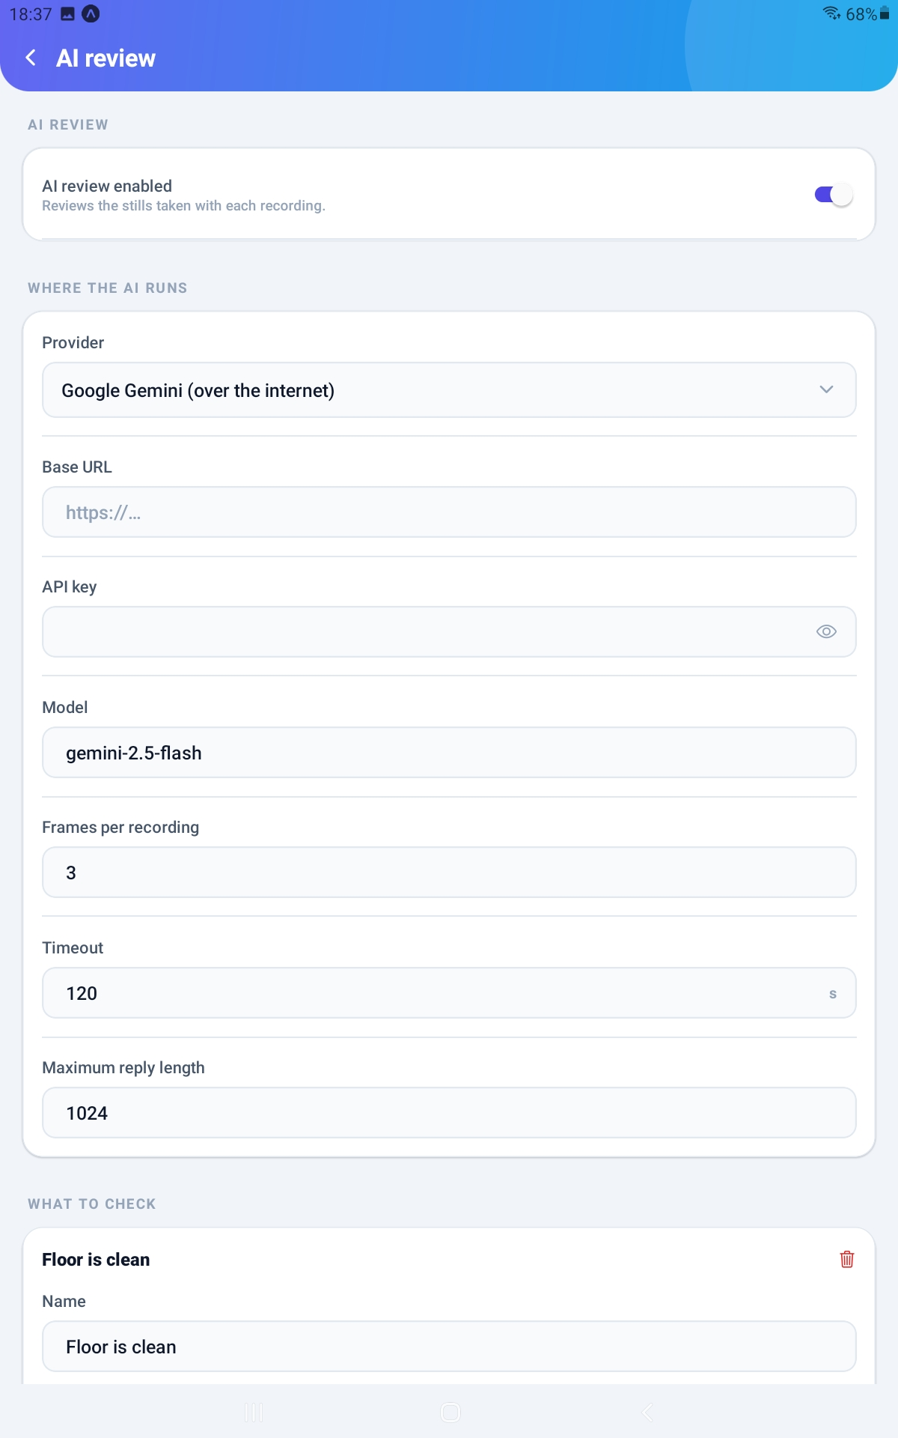
Figure 10. The AI review screen, with the provider, the model and the checklist.

IMPORTANT A hosted provider means photographs of your premises, and the people in them, leave your building. Confirm you are permitted to send them before switching it on. A model running on your own network keeps everything in-house.

PART 4 KEEPING IT HEALTHY

Step 11 Storage and Retention
On the Keeping recordings tab, set how long rounds are kept and what happens when they expire.
Video is by far the largest thing this system stores. A daily round across several slots adds up quickly.
Lever | Effect
Clip length | Directly proportional to size. The quickest win.
Quality | Medium is enough for most rooms.
Keep for | How long before old rounds are cleaned up. Zero keeps everything forever.
Then: Delete the video only | Keeps the record, the photographs and the scores; reclaims most of the disk.
Then: Delete the whole record | Removes it entirely - and that day then shows as a missed round.

IMPORTANT Automatic clean-up is not running on this version. Whatever you set here, old recordings will not be removed on their own - plan to review disk use by hand until that is fixed. Deleting a round by hand works exactly as described.

Step 12 Publish These Guides Into the App
Staff read documents from Profile then Help inside the app. You publish them from the web workspace, under Help.
Upload a PDF, give it a title, and set two things: where it appears, and who may see it. A document marked for managers is genuinely hidden from ordinary users - that is enforced when the file is fetched, not merely hidden from the list.
What are you setting? | What it does
Section | Which shelf it sits on. Choose the mobile-app shelf for documents staff should read on the phone.
Shown to | Users or Managers. Publish the User Guide to users and this one to managers.
PDF | The file itself. It must genuinely be a PDF.

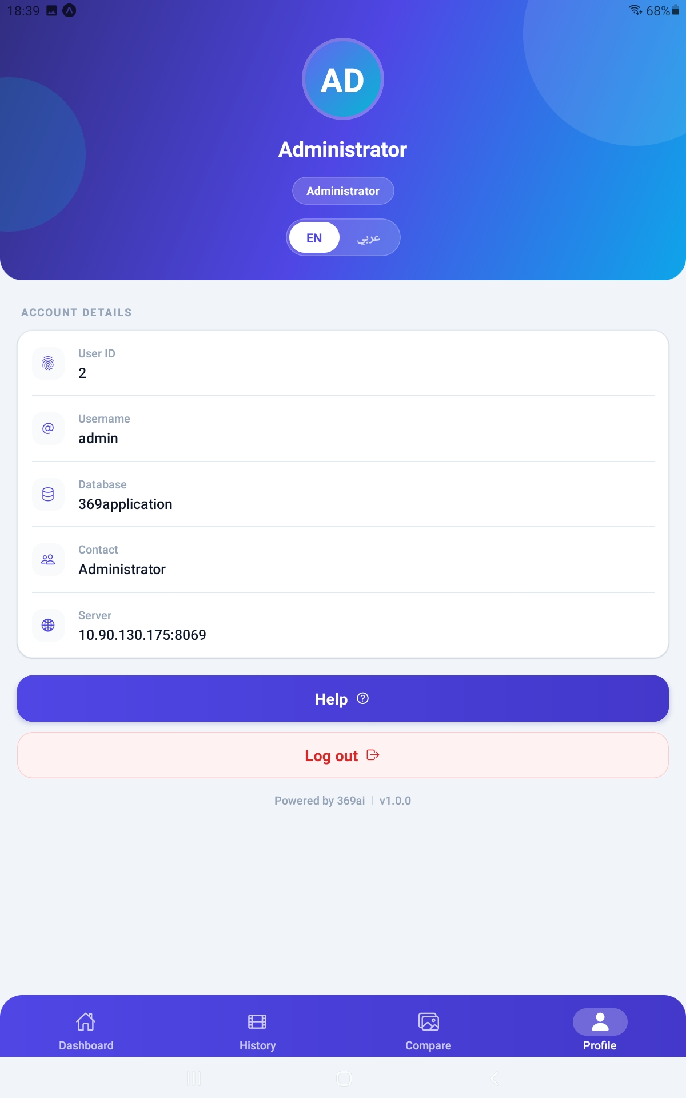
Figure 11. The administrator's Profile tab, showing the access badge and the Help button.

TIP Documents filed on the user-manual shelf do not currently appear in the phone app. Use the mobile-app shelf for anything staff need to read on their phone.

Step 13 Watch the Missed Rounds
The red chip on the Dashboard counts rounds that closed with nothing captured. Tap it for the list, by date and slot.
Read it for patterns rather than for individuals. A slot that is always missed usually means the window is at the wrong time of day, not that somebody is avoiding it.
What could go wrong? | What it usually means
One slot missed every day | The window does not suit the shift. Move it.
Missed only on certain weekdays | The round is scheduled on a day nobody is in. Untick that day.
A round missed right after you deleted it | Deleting a recording re-opens that day, so it reads as missed until it is captured again.
Everything missed since a certain date | Check the office timezone, and that the staff still have the role.

QUICK REFERENCE
If you want to... | Do this
Reach the setup screens | Dashboard → the gear icon → Configuration
Fix the schedule's clock | Settings → Daily rounds → Office timezone
Add or edit a round | Gear → Rounds → Add a round, or tap an existing card
Set what a view should look like | Settings → Showroom photos → tap a view
Make an existing round photo the original | Web workspace → open the round → Use this as the original
Stop video rounds entirely | Settings → Video → Allow a video round off
Restrict who may capture | Who can record → a named list (set this in the web workspace)
Re-score a round | Open it in History → Compare again
Read a round out of its clip | Web workspace → open the round → Read views from recording
Move the warning lines | Settings → Showroom photos → Warn below / Alert below
See what was never captured | The red Missed chip on the Dashboard
Publish a guide to the app | Web workspace → Help → the mobile-app shelf

Things to Remember
▪ The office timezone is the first thing to set and the most damaging to get wrong.
▪ Nothing is compared until a view has an original. This is the step people skip.
▪ Framing beats photo quality. Could not line up is nearly always an original taken from the wrong spot.
▪ A round's score is its worst view, not its average.
▪ Moving a threshold re-bands the whole history instantly, and rewrites no score.
▪ Exactly four views exist, and no fifth can be added.
▪ A window cannot cross midnight, and two rounds cannot overlap on a shared day.
▪ One recording per round per day. To let it be captured again, you must delete the existing one.
▪ Deleting a round entirely makes that day read as missed afterwards.
▪ Video rounds need the feature-matching software installed on the server, or they score nothing.
▪ A hosted AI provider sends pictures of your premises outside your building.
▪ Automatic clean-up is not running on this version - watch disk use yourself.
▪ Set Who may record from the web workspace, not the phone.
▪ Staff get no reminders. They must open the app to learn a round is open.
Set the clock, set the originals, then read Compare daily and Missed Rounds weekly.

--- End of Guide --- 369ai.Biz | 369 Showroom Check - Administrator Guide

